**Common problems of BENGBENG**

1. The code can not be burned

The reason why the code cannot be burned is probably that the Bluetooth switch is turned on, and the Bluetooth is also connected to the serial port Tx, Rx, which will affect the program burning. If the Bluetooth switch is turned off, the program can be successfully burned. Turn the Bluetooth toggle switch on the expansion board to OFF, as shown below.

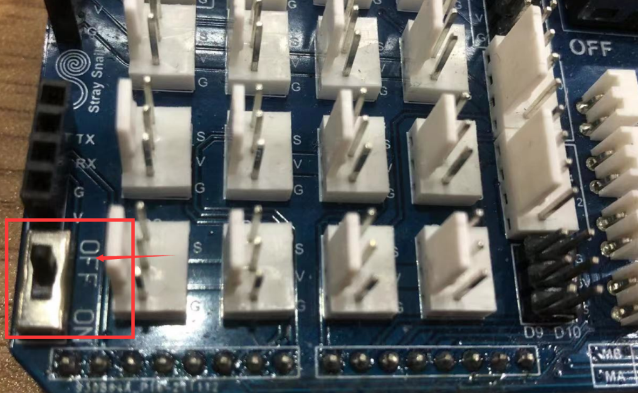

1. Bluetooth APP fails to control BENGBENG

（1）Burn the code of Bluetooth control firstly.

（2）Bluetooth is not turned on.

Turn the Bluetooth toggle switch to ON, as shown below.

